Correctif
Révisions de première année
Grammar

1 |  | Match the questions with the answers.
0 | Is Kaka a footballer? |  | 2 | Yes, you are.
1 | Are you British? |  | 3 | No, it isn’t.
2 | Am I a student? |  | 1 | No, I’m not.
3 | Is it 6 o’clock now? |  | 4 | Yes, she is.
4 | Is Angelina Jolie an actress? |  | 5 | No, he isn’t.
5 | Is Rafael Nadal an actor? |  | 0 | Yes, he is.

___/5 marks

2 |  | Complete the sentences with the correct form of be.
0 | A: Is John from the USA?  B: No, he isn’t.
1 | A: Are you from Barcelona?  B: Yes, I am.
2 | A: Are you French?  B: I’ m not French. I’m Spanish.
3 | A: What’s your teacher’s name?  B: Her name is Mrs Jones.
4 | A: Is this your book?  B: No, it isn’t.
5 | A: Are you a student?  B: Yes, I am .

___/5 marks

3 |  | Write the opposite of the underlined words.
0 | We’re in a band.  We aren’t in a band.
1 | Bob and Sarah are from England.  Bob and Sarah aren’t / are not from England.
2 | We aren’t at school now.  We’ re at school now.
3 | You aren’t my friends.  You’ re my friends.
4 | They’re good tennis players.  They aren’t / are not good tennis players.
5 | You’re from Switzerland.  You aren’t / are not from Switzerland.

___/5 marks

4 |  | Complete the sentences with the correct form of be.
0 | They aren’t from Brazil. They’re from Portugal.
1 | No, we aren’t / are not in a band. Are you?
2 | We aren’t / are not singers and we don’t like music!
3 | Are they your friends?
4 | She’ s a drummer in a new band.
5 | We’ re from London and we’ re English teachers.

___/5 marks

5 |  | Correct the underlined word in each sentence.
0 | That’s my father. Her name is Harry. |  | His
1 | We live in Manchester. Their house is very nice. |  | Our
2 | Here are my grandparents. His names are Tom and Amanda. |  | Their
3 | I have a lot of friends. Our best friend is Amy. |  | My
4 | Maria doesn’t like its name. |  | her
5 | When do you do our homework? |  | your

___/5 marks

6 |  | Complete the sentences.
0 | You live with your grandparents, don’t you?
1 | I’m Paul and this is my sister, Sally.
2 | Jack doesn’t like his new school.
3 | We love our new dog, Jelly.
4 | I like that cat. What’s its name?
5 | Claudia and Ellie don’t like their brothers!

___/5 marks

7 |  | Underline the correct answer.
0 | There are / is three banks near here.
1 | Are / Is there a supermarket on the High Street?
2 | There are / aren’t any bookshops in my street.
3 | There isn’t / aren’t a park here.
4 | Aren’t / Isn’t there a library near the market?
5 | Is / Are there any cinemas in the city centre?

___/5 marks

8 |  | Match the questions and answers.
0 | Why are you so happy? |  | 2 | Because he hasn’t got any friends.
1 | Why does Lisa go to the Internet café every day? |  | 5 | Because they don’t like sport.
2 | Why doesn’t Peter go out after school? |  | 1 | Because she’s got friends online.
3 | Why does Jessica like English so much? |  | 3 | Because she’s got a great teacher.
4 | Why haven’t your parents got a car? |  | 4 | Because they don’t like driving.
5 | Why don’t your brothers play football? |  | 0 | Because I’ve got a new bicycle.

___/5 marks

9 |  | Complete the sentences with the correct form of has/have got.
0 | We’ve got two cats and three rabbits at home.
1 | David hasn’t got / has not got a DVD player because he doesn’t like watching films.
2 | We’ve got a really nice French teacher.
3 | Has Laura got any brothers or sisters?
4 | I’ve got lots of DVDs because I love films.
5 | No, I haven’t / have not got your English dictionary.

___/5 marks

10 |  | Complete the sentences.
0 | Jose can’t speak English very well because he’s a beginner.
1 | Can you ride a bicycle?
2 | Sally is not musical. She can’t / cannot play the guitar.
3 | We can play volleyball but we can’t / cannot play football.
4 | My grandmother can’t / cannot use a computer because she’s very old and doesn’t understand technology!
5 | I was born in Paris. I can speak French.

___/5 marks

11 | Write the sentences.

0 | Clare / play tennis (+) / play volleyball (-)  Clare can play tennis but she can’t play volleyball.
1 | Antonio and Carlo / play football (+) / ski (-)  Antonio and Carlo can play football but they can’t ski .
2 | I / ride a bicycle (+) / ride a horse (-)  I can ride a bicycle but I can’t ride a horse .
3 | My parents / ski (+) / snowboard (-)  My parents can ski but they can’t snowboard .
4 | David / speak French (+) / speak German (-)  David can speak French but he can’t speak German .
5 | We / sing (+) / play the guitar (-)  We can sing but we can’t play the guitar .

___/5 marks

Vocabulary

12 |  | Write the countries.
0 | S p a i n
1 | T u r k e y
2 | J a p a n
3 | B r a z i l
4 | C a n a d a
5 | P o r t u g a l

___/5 marks

13 |  | Write the nationalities.
0 | Britain |  | British
1 | Belgium |  | Belgian
2 | Italy |  | Italian
3 | China |  | Chinese
4 | Poland |  | Polish
5 | Spain |  | Spanish

___/5 marks

14 |  | Complete the sentences.
0 | Anna is Polish. She’s from Poland.
1 | Georg is Swiss. He’s from Switzerland .
2 | Akiko is Japanese. She’s from Japan .
3 | Olga is Russian. She’s from Russia .
4 | Jeff is Canadian. He’s from Canada .
5 | Michelle is French. She’s from France .

___/5 marks

15 |  | Complete the sentences. Use the words in brackets.
0 | Kaka is a famous Brazilian footballer. (Brazil)
1 | Portuguese is a very difficult language. (Portugal)
2 | Belgian chocolate is very famous. (Belgium)
3 | Italian pizza is good! (Italy)
4 | Do you like Chinese food? (China)
5 | Istanbul is a Turkish city. (Turkey)

___/5 marks

16 |  | Are the sentences positive (+) or negative (-)? Write + or -.
0 | Coldplay are my favourite band. |  | +
1 | Volleyball is a fantastic sport. |  | +
2 | Horses are wonderful animals. |  | +
3 | Classical music is awful. |  | -
4 | New York is a great city. |  | +
5 | English grammar is terrible! |  | -

___/5 marks

17 |  | Write the words in each sentence in the correct order.
0 | a / city / Rome / fantastic / is |  | Rome is a fantastic city.
1 | sport / football / awful / an / is |  | Football is an awful sport.
2 | film / ‘Pretty Woman’ / is / a / great |  | ‘Pretty Woman’ is a great film.
3 | fantastic / Belgian / is / chocolate |  | Belgian chocolate is fantastic.
4 | friend / you’re / wonderful / a |  | You’re a wonderful friend.
5 | is / coffee / English / terrible |  | English coffee is terrible.

___/5 marks

18 | Write the words for Jenny’s family.
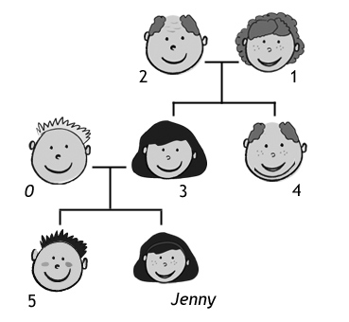
0 |  | father
1 |  | grandmother
2 |  | grandfather
3 |  | mother
4 |  | uncle
5 |  | brother

___/5 marks

19 | Complete the sentences.
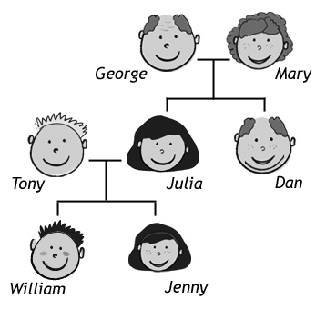
0 |  | Dan is George’s son.
1 |  | Jenny is William’s sister.
2 |  | Julia is Tony’s wife.
3 |  | Julia is Mary’s daughter.
4 |  | William is Jenny’s brother.
5 |  | Tony is Julia’s husband.

___/5 marks

20 |  | Write the numbers.
0 | a hundred and twenty |  | 120
1 | two hundred and ten |  | 210
2 | three hundred and forty |  | 340
3 | four hundred and sixty |  | 460
4 | a thousand |  | 1,000
5 | two thousand five hundred |  | 2,500

___/5 marks

21 |  | Write the numbers.
0 | 130 |  | a hundred and thirty
1 | 250 |  | two hundred and fifty
2 | 380 |  | three hundred and eighty
3 | 512 |  | five hundred and twelve
4 | 2,000 |  | two thousand
5 | 3,700 |  | three thousand seven hundred

___/5 marks

22 |  | Write the days of the week in order.
0 | Sunday, Monday
1 | Tuesday
2 | Wednesday
3 | Thursday
4 | Friday
5 | Saturday

___/5 marks

 | 23 | Match the pictures with the words in the box.
bored angry excited scared happy sad
 |  |  | 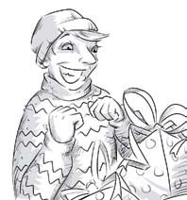 | 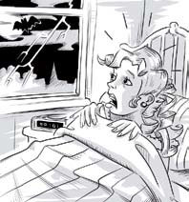
 | sad |  | excited | scared
 | 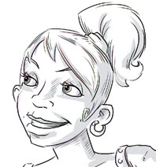 |  | 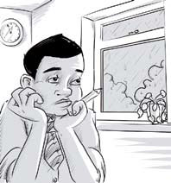
 | happy |  | bored | angry

___/5 marks

24 |  | Underline the correct answer.
0 | Bill’s excited / worried because it’s his birthday today.
1 | Don’t shout at me! Why are you so scared / angry ?
2 | I’m bored / scared because this film isn’t interesting.
3 | I’m very happy / sad because we’ve got a new cat.
4 | Jan is excited / confused because he doesn’t understand the question.
5 | Robert is worried / bored because he doesn’t know where his mobile phone is.

___/5 marks

25 | What are these sports? Write the words in the correct order.

0 | stinen | tennis
1 | wgnismim | swimming
2 | sahctliet | athletics
3 | bygru | rugby
4 | blelyalvol | volleyball
5 | stimgascyn | gymnastics

___/5 marks

 | 26 | What are the sports? Match the pictures with the words in the box.
skiing cycling snowboarding playing football horse riding playing basketball
 | skiing |  | horse riding | playing basketball
 | cycling |  | snowboarding | playing football

___/5 marks

27 |  | What are these sports? Complete the words.
0 | t e n n i s
1 | s k a t e b o a r ding
2 | r o l l e r b l a ding
3 | r u g b y
4 | v o l l e y b a l l
5 | g y m n a s t i c s

___/5 marks

28 | What are the sports?
skiing |  | riding a horse | playing basketball
cycling |  | snowboarding | playing football

___/5 marks

 | 29 |  |  | Label the picture. Use the words in the box.
living room bathroom garden hall bedroom kitchen
 | 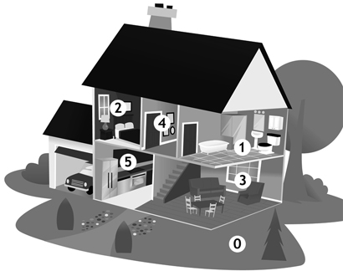
 |  | 0 | garden
 |  | 1 | bathroom
 |  | 2 | bedroom
 |  | 3 | living room
 |  | 4 | hall
 |  | 5 | kitchen

___/5 marks

30 |  | Complete the words. The first letter of each word has been given to you.
0 | There are four chairs around the kitchen table.
1 | We’ve got a great shower in the bathroom. The water is always warm.
2 | Dad always sits in his old armchair when he watches television.
3 | Please put the milk and butter in the fridge .
4 | Don’t touch the cooker because it’s very hot.
5 | Can you close the window , please. It’s very cold in here now.

___/5 marks

31 | Underline the correct answer.

0 | New Year’s Day is in ____.
 | a) July | b) January | c) June
1 | There are 28 days in ____.
 | a) March | b) December | c) February
2 | July, ____, September.
 | a) June | b) August | c) October
3 | ____ comes after winter.
 | a) Spring | b) Autumn | c) Winter
4 | Halloween is at the end of _______.
 | a) October | b) November | c) December
5 | In Australia it’s _______ in July.
 | a) summer | b) spring | c) winter

___/5 marks

Reading

32 | Read about Lucia’s class. Are the statements true (T) or false (F)?
Hi Alex
How are you?! I’m fine. I’m at school in London now and it’s really great. I’m in a class with ten students. We’re from lots of different countries.
Olga’s from Russia. She’s fifteen and I like her very much. She’s my best friend in the class. Her brother Andrej is also in our class. He’s a great tennis player and I like him too. Isabella’s Spanish and her English is very good. Her favourite band is Coldplay so we like the same music!! Marek’s from Poland. I don’t like him very much. He isn’t very nice.
Marcelo’s from Italy. We’re from the same city – Roma! His English is fantastic. Akiko is a Japanese girl. She’s sixteen and she’s from Tokyo. We’re in the same family here in London. There’s a Chinese girl in our class. Her Chinese name is very difficult so her English name is Lucy. And then Lisa is from Switzerland. She’s only fourteen and she’s from Basel. Her favourite language is French, not English! And finally Fred … he’s from Belgium. His best friend in the class is Andrej.
Please write soon.
Love
Lucia x
0 |  | Lucia is English. | F
1 |  | Lucia’s school is fantastic. | V
2 |  | Olga’s brother is Russian. | V
3 |  | Isabella’s English is awful. | F
4 |  | Marek is Lucia’s friend. | F
5 |  | Marcelo’s Italian. | V
6 |  | Akiko’s 15. | F
7 |  | Lucy is from China. | V
8 |  | Lisa is French. | F
9 |  | Lisa’s favourite language is English. | F
10 |  | Fred’s best friend is Russian. | V

___/10 marks

Listening

35 | Ecoute la jeune fille parler de ce qu'elle sait faire ou ne pas faire.  Complète le tableau suivant en français.  Piste audio: Can & can't

Sait faire | Ne sait pas faire
Parler italien  Jouer au tennis  Skier  Nager  Utiliser un ordinateur | Conduire une voiture  Parler français  Cuisiner  Jouer d'un instrument de musique

